Riphah International University

Gulberg greens Campus

Submitted by : Mahnoor Ahmed
Sap id : 80207
Submitted to : Mam Nayab Khalid
Lab # 05

Lab Task no. 1 Movie Ticket Counter (Unary Operators)
Create a class CinemaHall that tracks how many seats have been booked out of a fixed capacity, using increment/decrement to book and cancel seats.
Requirements:
1. Create a class CinemaHall with a private int bookedSeats (start at 0) and a final int capacity (e.g.
100）.
2.Write a method bookseat() that increment bookseat by using ++ but only if seats rem ains.
3. Write a method cancel booking()that decrements by usind - - buy never below 0.
4.. In main, book 5 seats, cancel 2, then display the status.
5.Write a method show booking() that print the number of booked seats and the seats remaining.

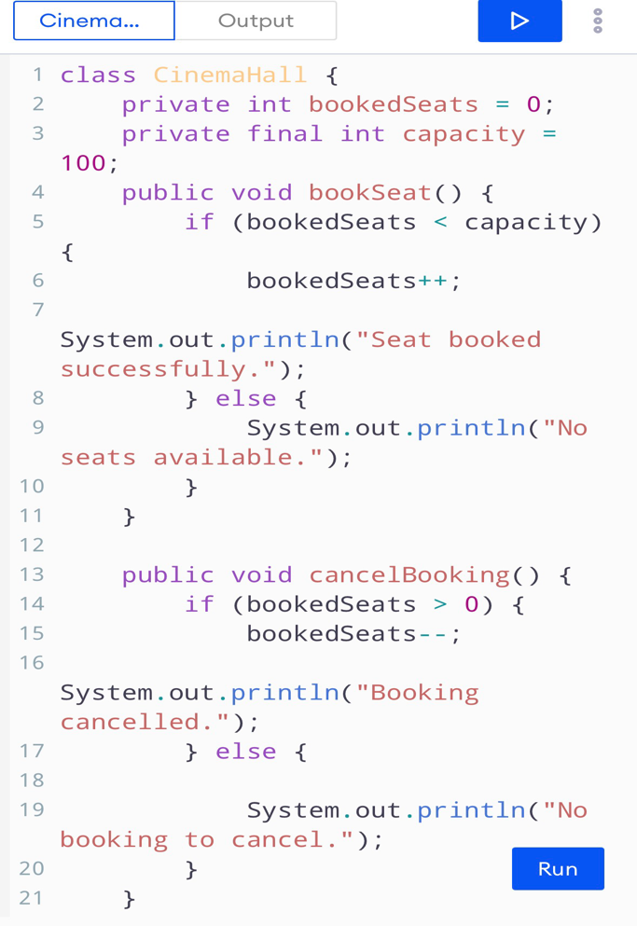
Program:
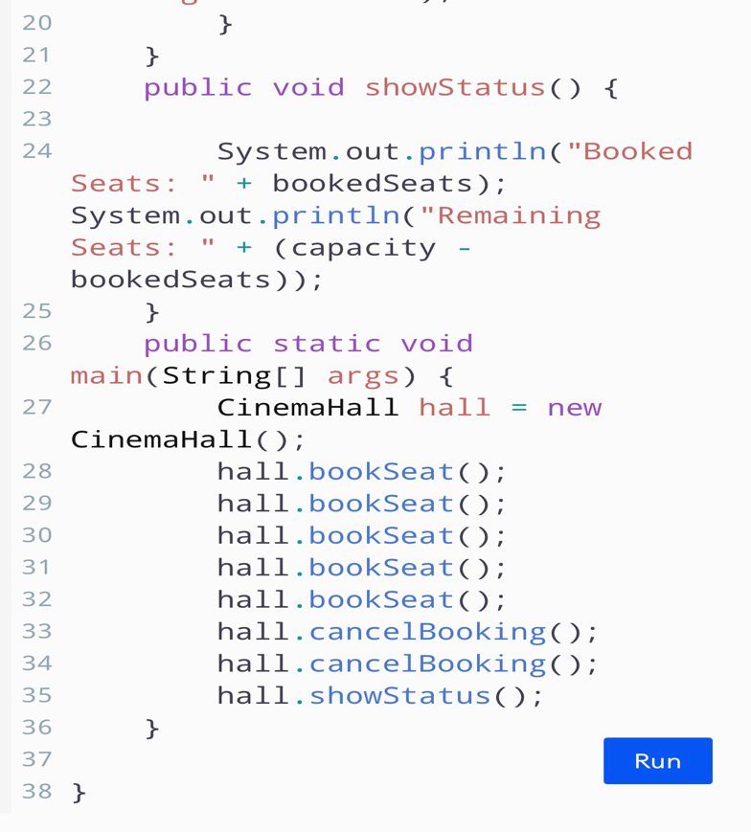
Result:

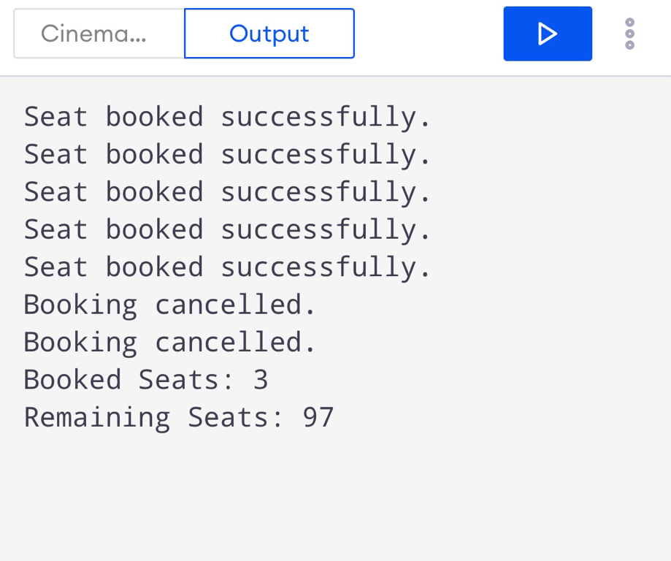

Lab Task 2: Utility Bill Category (if / else-if Ladder)
Create a class UtilityBill that classifies a household's electricity usage into a billing slab using an else-if ladder.
Requirements:
1. Create a class UtilityBill with attributes consumerName (String) and unitsConsumed (int).
2.Write a method classify slab() with else if / if else for units below 100, “Slab 1 “ for 100-200 “Slab 2 “ 201-300, “Slab 3” 301 -700
3. Compute and print an approximate bill amount based on a fixed rate per unit for each slab (choose your own reasonable rates).

Program:
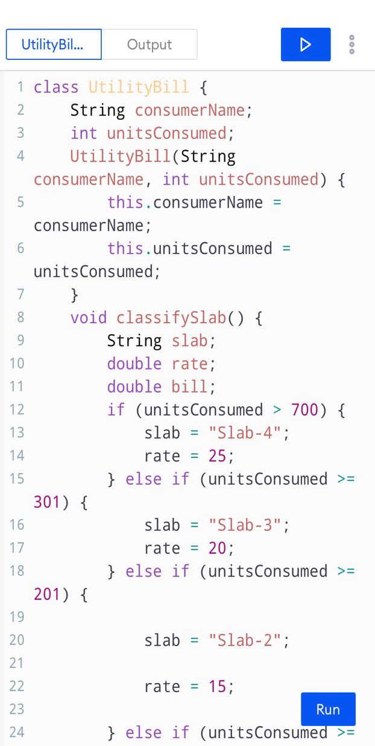
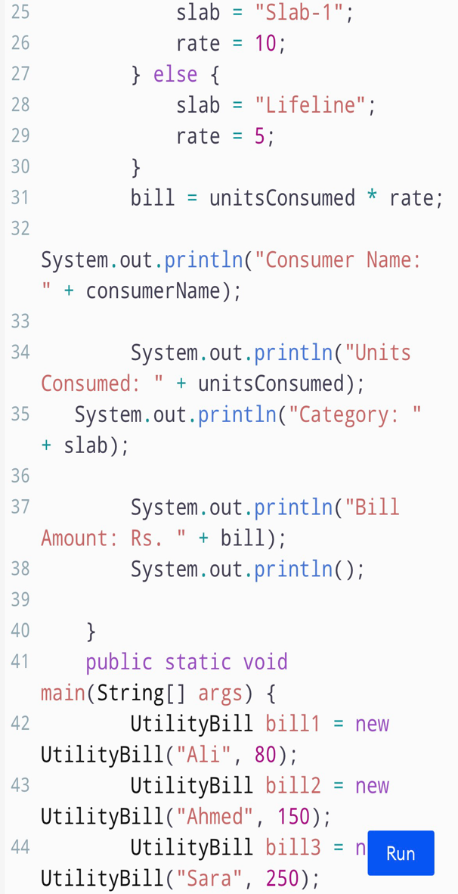
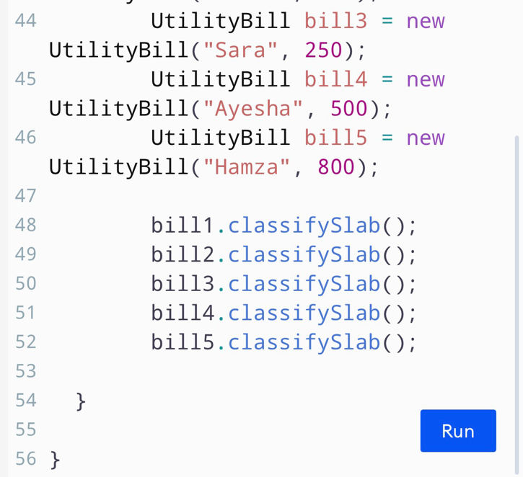
Result :
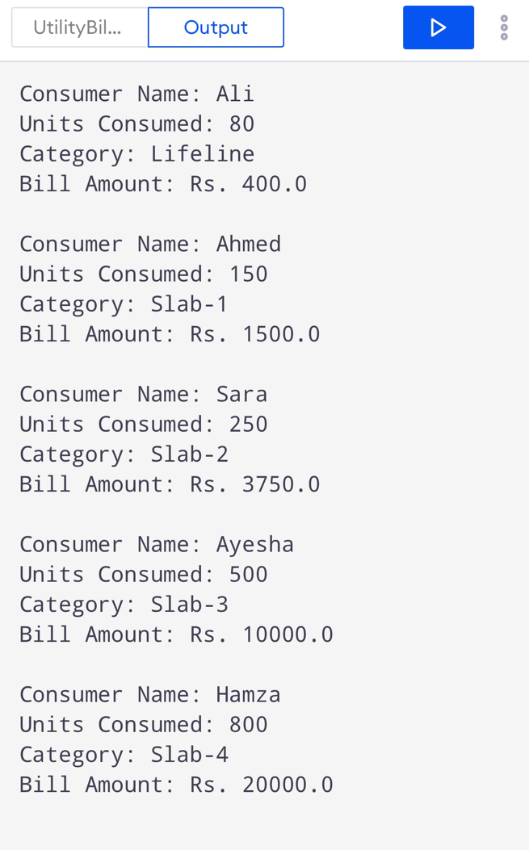

Lab Task 3: Bank Account Summary (Overriding toStringO)
passed to println(.
Requirements:
(String) and balance (double).
- ﻿﻿﻿Implement a constructor that initializes all three attributes.
- ﻿﻿﻿Override toString( to return a formatted string such as: "Account [1234-5678] - John Doe - Balance: $15000.00".
- ﻿﻿﻿In main, create two BankAccount objects with sample data.
- ﻿﻿﻿Print both objects directly with System.out. println and confirm your overridden toString) runs automatically.

Program:
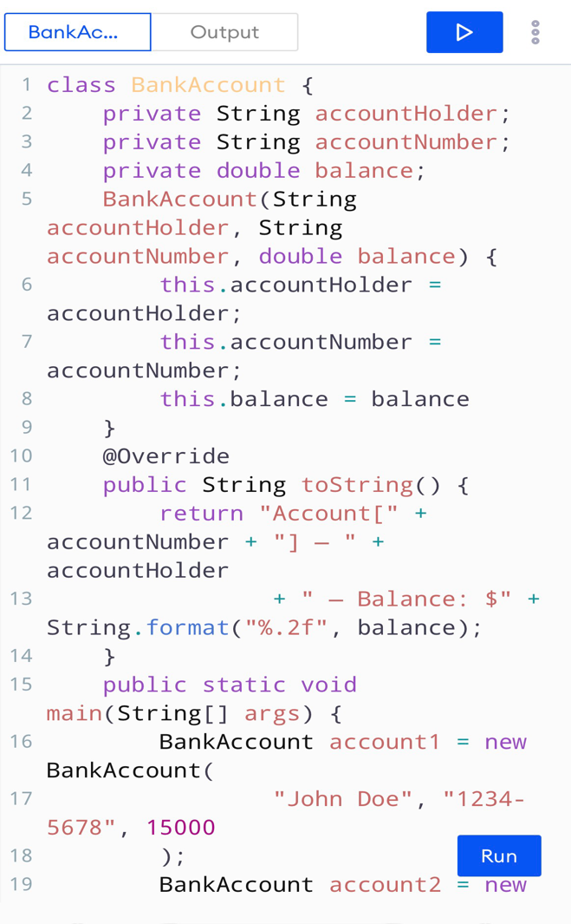
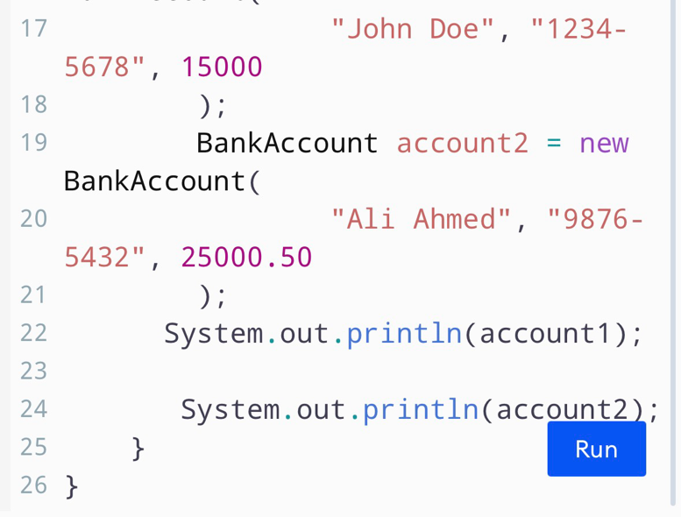

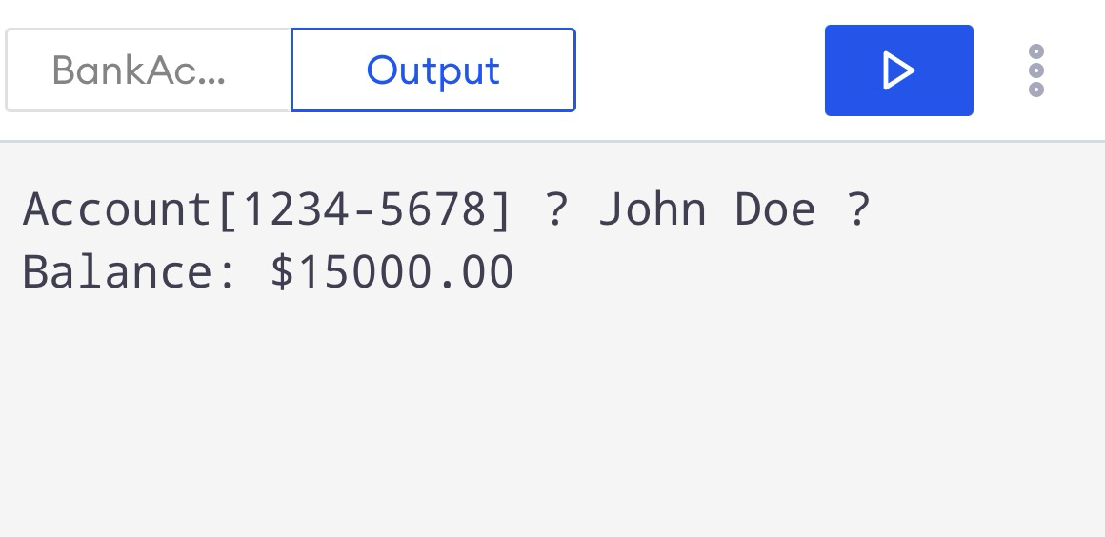
Result :

The End

